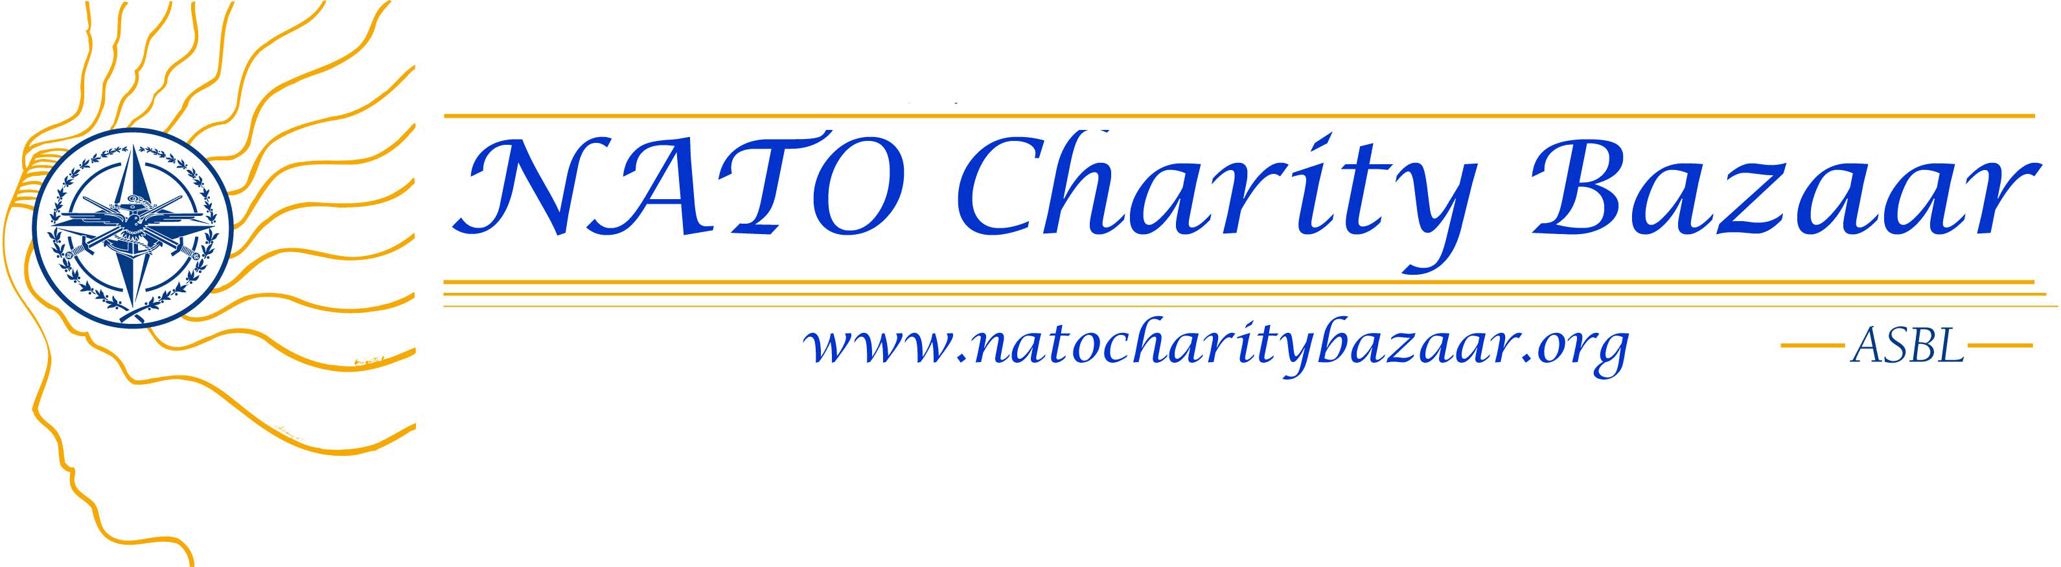

International Restaurant 2010
CONTACT FORM

ASSISTANT NATIONAL RESTAURANT COORDINATOR
Nation: _______________________________________________________
First name: ______________________________________________________
Surname: _______________________________________________________
Phone/Gsm: _______________________________________________________
E-mail (personal): ___________________________________________________
Postal address (husband’s office): _______________________________________________
____________________________________________________________________

Phone: (husband’s office): _______________________________________________________

Please return the completed form as soon as possible
and no later than ………….. to restaurant@natocharitybazaar.org

If you have any questions, please contact us:
- Fatma Demir, International Restaurant Coordinator. Gsm: 0484 511 955

